**Link: http://www.sudantribune.com/spip.php?mot147**

**Sudan People’s Liberation Movement/Army - North (SPLM-N/SPLA-N)**

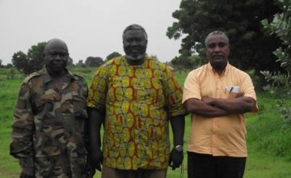

**SPLM-N deputy chairman Abdel Aziz Al-Hilu (L), Chairman Malik Aggar (M), and Secretary-General Yasir Arman (R)**

**Founded:** 2011

**Arabic Name:** Harakat Al-Sha’abi Li-Tahrir Al-Sudan-Al-Shamal

**Status:** The SPLM-N is a banned political party and military organisation

**Vision:** The SPLM-N describes itself as "a Sudanese national movement that seeks to change the policies of the centre in Khartoum and to build a new centre for the benefit of all Sudanese people regardless of their religion, gender or ethnicity background".

**Political Affiliations:** The SPLM-N founded the [Sudan Revolutionary Front (SRF)](http://www.sudantribune.com/spip.php?mot812) rebel alliance with the three main Darfur rebel groups in November 2011.